Chair Vija Vilcins
Vice Chair Kathy Aitken
Secretary Paula Traquair

Treasurer Ron Roffey

President Nicolas Bevan

Vice President Joyce Snipp

Vice President Jillian Smith
CABAHS


Charlton & Blackheath
Amateur Horticultural Society
Founded 1950
www.cabahs.wordpress.com

NEWSLETTER MARCH 2019

Tonight we welcome Jim Buttress, who will be talking to us about Greenwich Park. We have our usual Plant Sales Table, Raffle and Show Table and we have invited Jim to judge the entries for the latter.
Remember to pick up a seed potato tonight to enter in our Autumn Show. The variety this year is Pink Fir Apple.
Please remember to renew your membership for the coming year, or if you have done so already, you can collect your membership card this evening.
Copies of the (unconfirmed) minutes from our 2019 AGM are now on the website.

Next month is our Spring Flower display, April 15th. Please have a go!
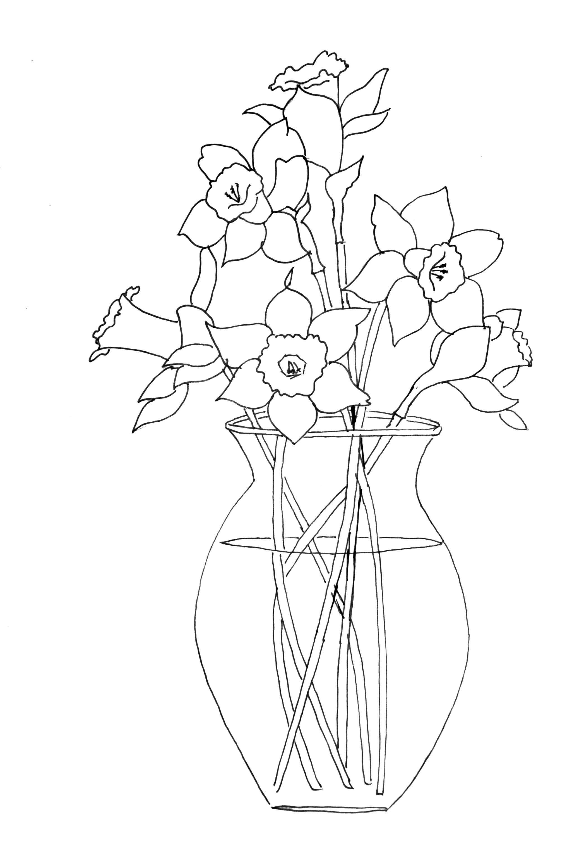
Classes:
- DAFFODILS / NARCISSI – 3 stems, one or more cultivars
- TULIPS – 3 stems, one or more cultivars
- SHRUBS, FLOWERING – 3 stems of any cultivar
- CAMELLIA, RHODODENDRON or AZALEAS
- SMALL VASE OF MIXED SPRING FLOWERS
- ANY POT-GROWN PLANT (indoor or outdoor)
- POT OF SPRING BULBS
- PIPIT DAFFODILS – competition
9 TEA CUP Floral Display – arrange at home, flowers from garden or shop.

My Garden this month:
Committee member Pat says …
“I love tulips. I mean I really love them and always have. I have planted them every year for the last 40 years or so in the ground, but due to a very full small garden, mostly in pots. And I spend quite a lot on them and buy the best quality bulbs I can find. This year I planted 14 pots as well as putting a few types in the ground and, given my garden is only 50 foot long, that's a lot of pots. But this year the squirrels have eaten 9 pot fulls so far! This is despite a layer of plastic netting and a layer of metal chicken wire kept in place with sticks and stones which I don't take off until the tulips are well grown and I know they can survive the onslaught. My garden backs on to wooded parkland, and the squirrels come with their monkey nuts and plant them in any bit of earth in pots and window boxes so we have a peanut tree forest by midsummer. This year in the back garden, they have worked out how to remove the sticks and stones on my pots, the two layers of wire, they have ripped off and cast aside the tulip shoots and run off with my bulbs. I feel heartbroken and Spring won't be the same for me this year.
Bright ideas anyone? Squirrels, just you wait until next year..!”

Garden Visits: Do have a look at all the garden visits Anna is arranging! They are on the website and Noticeboard. The Secret Garden visit on 1st May will be a group visit not a coach trip, it looks mysterious and exciting. Then RHS Wisley is on 10th May, just a few seats left, the Greenwich Roof Garden is 5th June and Chenies Manor on 14th July. Please be sure to have the correct money ready and sign up with Anna tonight.

Dates for your diary
- Hidden Horticulturalists exhibition at RHS Lindley Library 4 March – 6 May Mon-Fri. 200 years ago the RHS created the National School of Horticulture which went on to influence the ways in which we garden today and produced some of the famous names, including Joseph Paxton .
- John Brookes: His Landscape Legacy lecture by Dr. Barbara Sims, part of the Gardens Trust Winter Lecture Season at The Gallery, 77 Cowcross Street, EC1M 6EL 27th March 6-8pm, £15.
- Hall Place talk: “A funny thing happened on the way to the potting shed” March 20th at 2.30, tickets £4.25 – Phone 01322 621238 to book.
- Friends of Oxleas Woods – Guided walk, 24 March, 4-6pm
Walk and talk about the Houses in Castle Wood and Jack Wood. See their Facebook page or book by e-mailing the Secretary at suereeve@virginmedia.com
- Country Living Fair – Alexandra Palace – March 28-31
Tickets from £8.50, lots of stalls for house and garden.
- Chiswick Camellia Show 2019 – 1st-31st March
Open every day, plus a special Festival Weekend March 23/24th

Pat’s10 jobs for March:
1. Cut down any remaining growth on perennials and grasses left from winter but avoid damaging any new shoots.
2. Lift and divide any overcrowded summer flowering perennials such as Astrantia and Hemerocallis once new growth appears.
3. Remove the recently flowered heads of primroses and sow the green seeds on pots of compost and cover with grit. These can be left outside or in a cold frame until the new plantlets emerge.
4. Plant roses now, adding some mycorrhizal fungi (available from garden centres) to the planting hole to encourage the roots out into the surrounding ground.
5. When planting new plants add some home made compost to the planting hole and a little around the stems when planted.
6. Sow hardy annuals now such as poppies and Ammi majus outside and harden off any annuals already sown under glass by putting outside or in a cold frame.
7. Direct plant shallots and onion sets 4inches apart leaving the tops just showing
8. Harvest winter crops like kale and purple sprouting broccoli before composting any un-diseased plants.
9. Germinate tomatoes, peppers and chillies indoors on a window sill or in a heated propagator.
10. Watch out for slug and snail damage on young plants and emerging shoots and deal with as you wish.
cabahshortisoc@gmail.com


