Chair Vija Vilcins
Vice Chair Kathy Aitken
Secretary Paula Traquair

Treasurer Ron Roffey

Membership Ross Howie

President Nicolas Bevan

Vice President Joyce Snipp

Vice President Jillian Smith
CABAHS

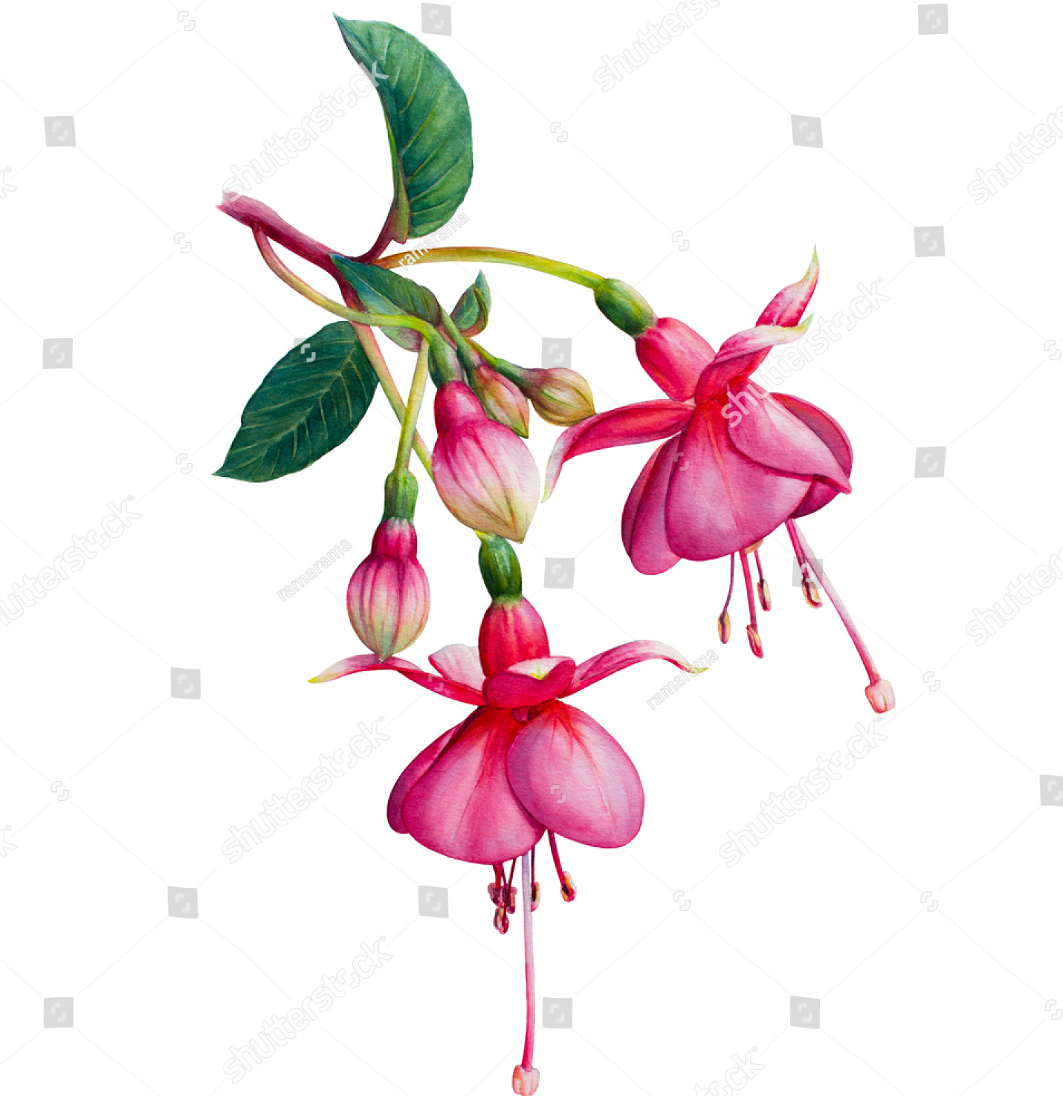
Charlton & Blackheath
Amateur Horticultural Society
www.cabahs.wordpress.com

NEWSLETTER SEPTEMBER 2018
Welcome to our autumn flower, fruit and vegetable display! Could members who are exhibiting please place entries in one of the classes below and be sure to include your name and details of plants.

- Vase of flowers, 3 stems of 1 cultivar.
- Bowl of mixed flowers (max.12″x12″).
- Vase of shrubs or foliage, 3 or more stems, mixed.
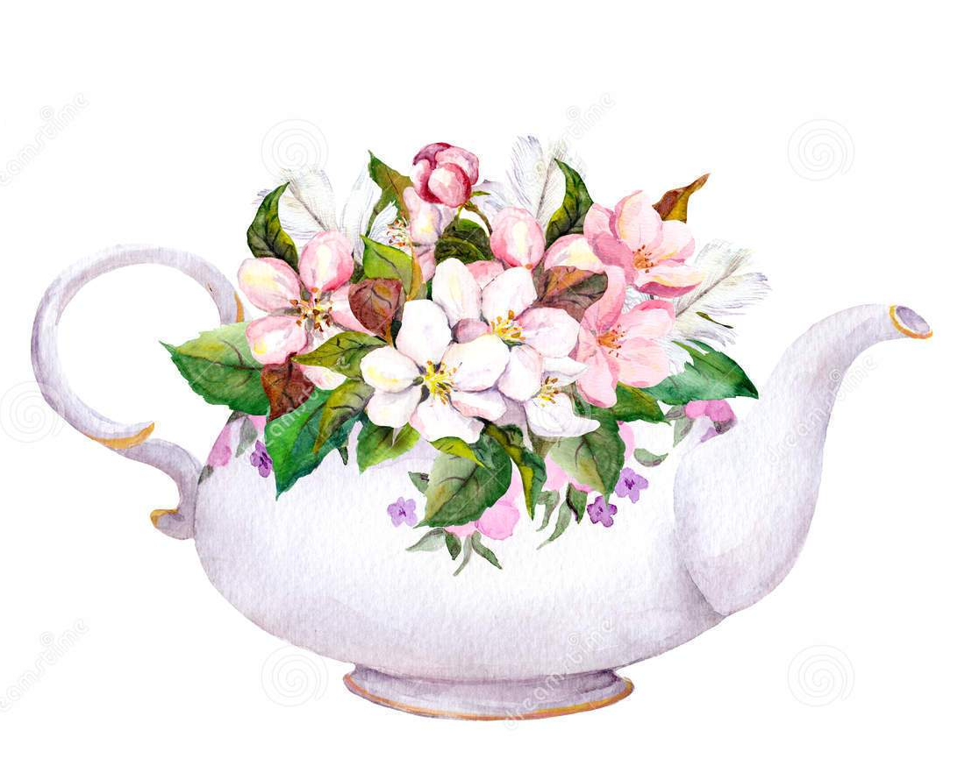
- Five Fuchsia blooms, 1 or more cultivars (flower heads only, containers supplied).
- Ornamental pot plant (incl. cacti & succulents).
- Display of fruit, 1 or more types.
- Display of vegetables, 1 or more types.
- Tomatoes (dish of 5).
- Display of herbs.
- Preserves: jam, jelly or marmalade, chutney or relish.
- Baking: CABAHS Courgette & Lemon Cake.
- TEAPOT Floral arrangement.
- Competition: Potatoes (washed, in named transparent bag).

Horn Fair, Sunday 14th October
If any members have potted up plants for sale at the Horn Fair, please let a member of the committee know and we will arrange to collect these during the week prior to the event. We would also be grateful for any volunteers who can help staff our stand during the day. Once again, please let a member of the committee know, or email us at cabahshortisoc@gmail.com

Outing to Hyde Hall, Friday 21st Sept
Please note the alteration to the usual pick up times: First: 9.00am Court Rd Bus Stop Mottingham village end / Second: 9.15am Charlton House / Third: 9.30am Westcombe Park Road, by Tudor Grange Care Home.

Dates for your diary
- Garden designer Anthony Nolan will be giving a talk at the Eltham & Avery Hill Gardens Society on 18th October, details on “Whats On” page of our website.
- The Horniman Museum has opened a new Grasslands Garden, devised by James Hitchmough.
- Maryon Park Community garden – Urban harvest open day, next Saturday 22 September 10-4pm.
- Six gardens, courtyards and terraces inspired by Islamic cultures feature in the newly opened Aga Khan Centre in London.

- London Open House: 23rd Sept 10-5 V22 Louise House, Dartmouth Rd Forest Hill SE23 3HZ Open 10-5, guided tours every 60 mins. Grade II listed industrial school, plus a newly created garden.
- Woodlands Farm Trust on Shooters Hill are having their London Harvest Festival 29th September, 10-5pm
- The Garden Museum is hosting a series of talks. On 2 October Tom Stuart-Smith will be speaking. 7.00 – 8.30 and tickets need to be booked in advance.
- RHS LONDON SHOWS: October
See them in London this year, before they move in 2019 to Wisley or Hyde Hall.
RHS Harvest Festival London Show 2-3 October
RHS Urban Garden Show 27-28 October
- Hall Place Plant Centre Not a particular date for this, but don’t forget to look in if you are visiting Hall Place in Bexley DA5 1PQ. Its small but a little gem, a good selection of plants and needs our support to keep it going.

10 jobs for September:
1. If not already done, order spring bulbs ready for autumn planting
2. Plant narcissi, crocus and hyacinths for flowering in spring. Where squirrels are a problem cover with netting or chicken wire until shoots emerge.
3. Deadhead dahlias regularly and protect the flower heads by planting an upturned flower pot on a stake with screwed up newspaper inside and check each day for earwigs.
4. Deadhead buddleia regularly for a continued flower display.
5. Leave heads on mophead and lacecap hydrangeas through winter to give some protection to emerging new buds for spring.
6. Control powdery mildew by removing affected leaves regularly on plants and vegetables and water frequently.
7 Lift maincrop potatoes once the crop has matured, as slugs will damage tubers that remain in the ground too long.
8. Finish taking cuttings of tender perennials eg pelargoniums, to allow roots to form before winter.
9. On tomato plants, remove very small green fruits to allow larger fruits to ripen. Make chutney with green tomatoes that don't ripen.
10. Leave windfall apples and pears on the ground to feed garden birds.

- Please note that from next month we will not begin selling plants from the sales table before 7.30, in order to allow time for set up and labelling.

- The Society is organising a monthly coffee morning to be held at Charlton House. The first meeting will be on October 1st, in the Charlton House Café. All members are welcome. It would be appreciated if you could give us some indication of your support for this new venture. Please speak to Angela Burr.

- Tonight we are offering members the opportunity to get a bag of Pipit narcissi free for the purchase of one bag of other bulbs (one offer per member). Grow them in a pot and enter them in the Pipit pot class in next year’s Spring Show!

Our next meeting is on Monday October 15th, when Dr John Hughes will return to tell us about his visits to Monet’s Garden.

